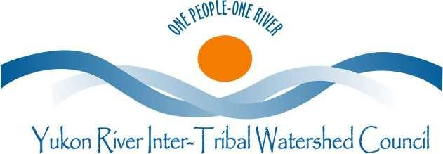
2019 Summit Donation Form
Check one | Support Level
 | $5,000
 | $2,000
 | $1,000
 | $ 500
 | Other:________

Make checks payable to: Yukon River Inter-Tribal Watershed Council
Donor Information
Organization name:
Address:
City: | State: | Zip:
Primary Contact: | Name: | Position:
Email: | Telephone: | Fax:
Please add me to your mailing list: Yes No

Donor Note:

The YRITWC is grateful for your support

